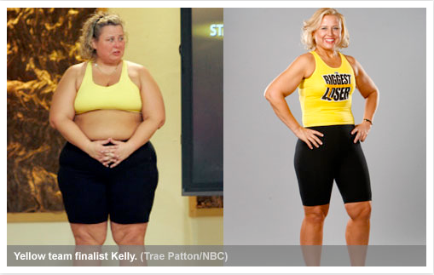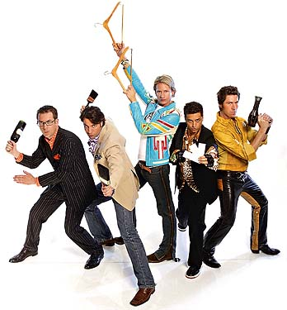
Regardless of the type, makeovers ardently promote an essentialized and authentic idea of self that is stable, coherent, and locatable, where gender unambiguously correlates to sexed identity.

USW26 – Sex and the Citizen
Spring 2011
Project #2 – Make Over Nation
Project due on Friday, April 29th
by 9pm.

According to Brenda Weber, Makeover T.V. constitutes a pedagogical “citizenship project” that teaches the viewing population how to be and to recognize real citizens. Your assignment will – in the language of General Education – “de-familiarize” the Makeover by creating your own digital critique. Your project should run 3-5 minutes and include both visual and aural components. It can be a short film (e.g. using iMovie), a Prezi, or a Powerpoint/Keynote slideshow with audio commentary. It may take one of the following two forms:

- mini-documentary – think of this as an essay using visual and audio components to explore and analyze specific key elements of the makeover genre. (see more details below)

- makeover narrative – you may create your own makeover story in one of two ways: a) your own or someone else’s personal transformation (in which case you’ll want to address the larger significance of this story) or
b) a parody of the makeover genre. In either case, the point is to create your own version of the makeover “spectacle” that offers critiques of and insights into the normalizing effects of the publicly staged makeover. (see below for important notes on parody)

Getting Started, practical steps:

- Carefully read the assigned chapters from Brenda Weber’s Makeover T.V.: Selfhood, Citizenship, and Celebrity, paying particular attention to Weber’s definition of the makeover genre.
- Watch at least one example of a contemporary makeover T.V. program. You may browse through the various examples posted on the isite or select some examples of your own. If you have never viewed a makeover T.V. show, you may wish to watch a few of them, just to get a better feel for the genre.
- Submit a brief, (approximately) 250 word proposal/pitch to your section’s discussion board on the section tab of the site (respond to the thread begun by your TF) by Monday, April 18 at 5 pm.
- Submit the final project to yousendit.com by 9:00pm on Friday, April 29th.

Questions and theoretical models to consider:

- What do Makeover T.V. shows teach viewers about U.S. belonging or “Americanness”? What differentiates the kinds of “Before” bodies depicted in the different programs? What differentiates the “After” bodies?
- While you may focus on the contemporary wave of makeover t.v. programming, as an alternative, you are also encouraged to explore how history itself sometimes takes the shape of a makeover narrative, where an individual subject (or collectivity) transforms from “Before” (signifying cultural/racial/ethnic incoherence, gender or sexual non-normativity, “alien” cultural or legal status, lacking in agency and “choice”) to “After” (signifying success, confident selfhood, “naturalization” in both senses, and legibility as possessing full citizenship). (For example, Teddy Roosevelt’s “manly” transformation discussed in lecture or how Chinese Americans were transformed from the “Yellow Peril” of the 19th century to the more contemporary “Model Minority.”)
- As you create your digital documentary or makeover narrative, consider the kind of “citizenship project” you wish to document: will yours be a story of a specific “Before” and/or “After” body or of a collectivity of bodies that must be made to fit dominant or conventional understandings of authentic citizenship? What roles do visible gender, sex, and race difference play in the transformation of "Before" into "After" bodies?
- What forms of subversion, if any, will you depict or allow in your project?
- What kinds of “silences” (or stigmas, or exclusions) will you expose or “cover” in your documentary or makeover narrative?

Some important notes on form:

Why must this project take a visual – rather than written - form? If we are using the genre of the Makeover as our “primary text” in this assignment, then the best way to analyze it,to “quote” it,and to contextualize our analysis is to use a visual format. In other words, because the Makeover genre uses visual formats to ‘teach’ United States belonging, the best way to engage and critique these lessons is a visual format.

Notes on documentary:

Think of the documentary as a “visual essay” in which you may combine your analysis with actual depictions of the images and stories you are analyzing. In this case, your visual essay will be accompanied by your voice (an aural version of the written essay), so you will be able literally to “show” visuals as you verbally “tell”your analysis.

Notes on parody:

First, a definition from Wikipedia: “A parody (also called send-up, spoof or lampoon), in contemporary usage, is a work created to mock, comment on, or make fun at an original work, its subject, author, style, or some other target, by means of humorous, satiric or ironic imitation. As the literary theorist Linda Hutcheon (2000: 7) puts it, ‘parody … is imitation, not always at the expense of the parodied text.’ Another critic, Simon Dentith (2000: 9), defines parody as ‘any cultural practice which provides a relatively polemical allusive imitation of another cultural production or practice.’ Often, the most satisfying element of a good parody is seeing others mistake it for the genuine article.”

As with the documentary format, the optimal way to parody or spoof something is to use a medium similar to the thing being parodied. Hence, a parody of a politician’s speech might take the form of a public speech, and a spoof of a newspaper op-ed should resemble in form and method an actual op-ed article. A crucial point to remember is that parody is not simply about generating comedy or “making fun” of a subject; it is a complex reiteration (sometimes amplification) of a particular set of tropes or assumptions that might often go unnoticed in their original form. For instance, we might think of the tropes that Black comedian Eddie Murphy parodies in his 1984 SNL performance “White Like Me”: using an expository journalistic tone similar to that used by John Howard Griffin in his 1961 book, Black Like Me, Murphy explores and exposes a hidden world of race privilege where whites “give things to each other for free.” Murphy’s performance of white manhood is excessively stiff (“they hold their butts real tight when they walk”) and he is flummoxed to discover that whites needn’t pay for their newspapers or apply for loans (they receive free money from banks overseen by other whites). These excessive iterations of white privilege are humorous in large part because they are excessive but, more importantly, because they are grounded in the truth of actual race inequality and whites’ insouciant denial of this privilege. A successful parody of Makeover T.V. is similarly capable of revealing the tropes and tactics through which “Before” and/or “After” bodies are managed to promote conventional understandings of authentic citizenship.

