Instructor: Dr. Ariane Liazos Meeting Time: Mondays 1-3
liazos@fas.harvard.edu Classroom: William James 303
Office: 237, One Bow Street Office Hours: By appointment

Social Studies 68ec: Education and Community in America
Universities and Community Engagement, c. 1890-2015

“Life and education must never be separated.
We must have more life in our universities, and more education in our life.”

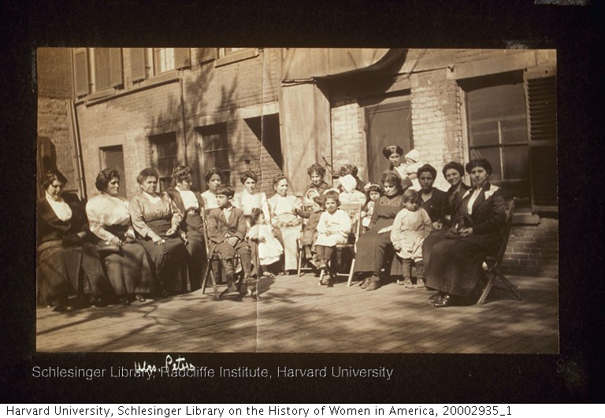
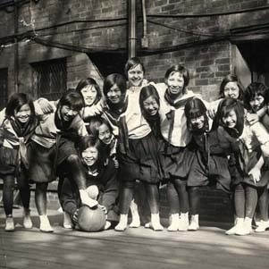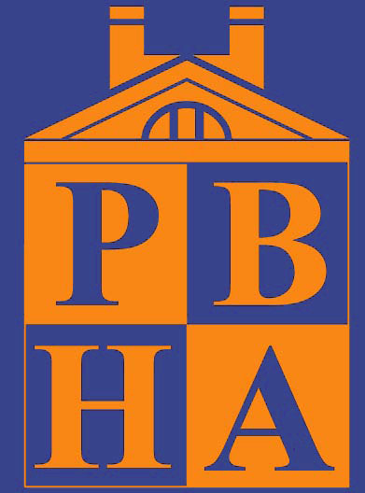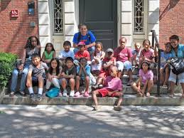

Catalogue Description

Explores efforts to realize the civic purpose of American universities, particularly in terms of attempts to engage local communities through educational outreach programs. Examines major periods of experimentation and innovation in the 20th and 21st centuries, from the settlement house movement of the early 1900s to recent efforts to revive the public mission of universities through service-learning and other forms of civic education. This course is an activity-based learning course, limited to students who are concurrently participating in education-related service programs affiliated with Harvard. Class discussions and assignments will make active links with students’ service work. Enrollment capped at 12.

Course Overview

This course explores a variety of attempts of students and faculty to engage their communities in educational programs from the late nineteenth to the early twenty-first centuries. Today, the widely accepted model for university outreach programs is based on the concept of reciprocity: the notion that members of the university and the neighboring community both benefit from their joint endeavors. But this has not always been the case. Together, we explore the origins and evolution of this concept. Our goal is to better understand the present moment – the values and assumptions that underlie contemporary models of engaged universities.

Course readings include both secondary works and primary materials. We examine national trends, and each week we relate these trends to events here at Harvard with a particular focus on the history of Phillips Brooks House. The course proceeds chronologically, beginning with the Progressive era and ending with contemporary trends. The majority of readings directly address the efforts of universities to engage their local communities through various types of outreach programs. Other readings focus more broadly on student activism, community education programs, and the public or civic purpose of universities in a democracy.

This class on higher education in a democratic society is based on active participation and collaborative learning among students, faculty, and community partners. We will explore the ways in which your readings in the social sciences and your service experiences inform each other. Our goal is to help you develop a fuller understanding of your role as a student, a volunteer, and a member of a larger community.

Each week, we will (generally) follow this schedule:

- Before Monday at 9:00 AM – Complete assigned readings for the week; post 1-3 questions or comments on Canvas regarding the readings that will guide our class discussion
- During class on Monday – Discuss readings, student presentations, joint determination of questions to be addressed in weekly journal
- During the week – Participate in service program(s)
- Before Friday at 5:00 – Submit journal entries, reflecting on readings and their relation to service

Grades

10% - Oral Presentation
20% - Weekly Journal Entries (due Fridays at 5:00 PM)
10% - Expansion of Journal Entry (due 10/12 or 11/23 at 11:59 PM)
10% - Project Proposal (due 10/18 at 11:59 PM)
40% - Final Project (due 12/11 at 11:59 PM)
10% - Participation

Late assignments will be subject to a 1/3 grade deduction per day. (An A becomes and A-, an A- becomes a B+, etc.) Grades follow the system set out in the Student Handbook. Please see:
http://static.fas.harvard.edu/registrar/ugrad_handbook/current/chapter2/grading_system.html

Assignments

Oral Presentation (8-10 minutes) – Over the course of the semester, each student will give a presentation that addresses the following questions: What is your service program? What motivates you to participate? What questions do you hope that this class will answer for you regarding your service experience? Have the course readings helped you to view your service in a new light? Do your experiences challenge some of the claims made in the course readings?

Weekly Journal Entries (2 pages) – At the end of each class, we will brainstorm a list of questions that relate the week’s readings to your service experience. I will email them to you and ask you a.) to respond personally to the questions and/or b.) to use them to frame a conversation with a community partner. You will write a total of ten informal entries over the course of the semester (you may skip one week).

Expansion of Journal Entry (5-7 pages) – You will revise and expand one of your weekly journal entries, relating your thoughts to course readings more fully. This more formal piece of writing should have a thesis and argument supported by evidence from the readings and your service experience. It should also include references and a bibliography (Chicago or MLA).

Project Proposal (2 pages) – In the middle of the semester, you will submit a proposal for your final project. It should specify 1.) which of the two options you are selecting (see below), 2.) which course readings will play a central role in your project, and 3.) what additional research you propose to incorporate. After you submit it, you will meet with me to discuss your proposal the week of 10/19-10/23.

Final Project –
Option A: Organizational History (10-12 pages) and Accompanying Synopsis (c. 1000 words): You will write an intellectual and/or institutional history of your partner organization. You should model this history on those you encounter in the assigned readings. It should relate your specific organization to the wider educational trends covered in course readings, but it will also involve additional research. Part of your research will take place in your community, whether interview based or archival. It should also include references and a bibliography (Chicago or MLA). You will also submit a synopsis and adaptation of your history in the form of either an op-ed or a brief history that would be appropriate for publication on your partner organization’s website.

Option B: Community Resource/Asset and Accompanying Essay (10-12 pages): You will identify an existing community need/problem and create a resource for your partner organization to help address that need/problem. You must obtain written documentation from someone at your partner organization that confirms a need for your proposed resource, to be submitted with your proposal. Possibilities include a web page, lesson plan, brief video, etc. With this final assignment, you will also write an accompanying paper, drawing on the assigned readings of the course to explain history of the problem/need, why you chose to intervene in this particular way, and why your intervention is appropriate. It should also include references and a bibliography (Chicago or MLA).

Participation – This component of your grade includes participation in class discussions and questions/comments posted to the discussion board.

The Honor Code

As you complete all of the assignments for this course, please remember your commitment to uphold the Harvard College Honor Code:

Harvard College is an academic and residential community devoted to learning and the creation of knowledge. We – the academic community of Harvard College, including the faculty and students – view integrity as the basis for intellectual discovery, artistic creation, independent scholarship, and meaningful collaboration. We thus hold honesty – in the representation of our work and in our interactions with teachers, advisers, peers, and students – as the foundation of our community.

The Harvard College Honor Code

Members of the Harvard College community commit themselves to producing academic work of integrity – that is, work that adheres to the scholarly and intellectual standards of accurate attribution of sources, appropriate collection and use of data, and transparent acknowledgement of the contribution of others to their ideas, discoveries, interpretations, and conclusions. Cheating on exams or problem sets, plagiarizing or misrepresenting the ideas or language of someone else as one’s own, falsifying data, or any other instance of academic dishonesty violates the standards of our community, as well as the standards of the wider world of learning and affairs.

For more information, see: http://honor.fas.harvard.edu/honor-code.

Course Schedule

Week 1 (9/2) Introduction to the Course (Shopping Week)

In class for discussion: statements of purpose, Phillips Brooks House 1909, 1974, and 2015

9/7 – Labor Day (No Class)

Week 2 (9/14) Civic Education and the Mission of American Universities

Derek Bok, “Purposes, Goals, and Limits to Growth” and “What to Learn,” Higher Education in America (Princeton: Princeton University Press, 2013), 28-43, 166-82.

Harry Boyte and Elizabeth Hollander, “Wingspread Declaration on the Civic Responsibilities of Research Universities,” June 1999.

At Harvard –

Ellen Condliffe Lagemann and Harry R. Lewis, “Renewing Civic Education: Time to Restore American Higher Education’s Lost Mission,” Harvard Magazine (March-April 2012): 42-45.

Stephanie Garlock, “Educating ‘Citizens and Citizen Leaders’ – The New College Dean Aims to ‘Discuss What I Think is Undiscussable,” Harvard Magazine (July-August 2015): 24-26.

Week 3 (9/21) Progressive Education, Citizenship, and Universities

Lee Benson, Ira Harkavy, and John Puckett, Dewey’s Dream: Universities and Democracy in the Age of Education Reform (Philadelphia: Temple University Press, 2007), 3-44.

Michael S. Roth, “Pragmatism: From Autonomy to Recognition,” Beyond the University: Why Liberal Education Matters (New Haven: Yale University Press, 2014), 62-94.

At Harvard –

A. Lawrence Lowell, “Inaugural Address of the President of Harvard University,” Science 30, no. 772 (Oct. 15, 1909): 497-505.

Week 4 (9/28) Social Science and Social Reform: Settlement Houses and Universities

Nicholas Longo, “Hull House,” Why Community Matters: Connecting Education with Civic Life (Albany: SUNY Press, 2007), 45-66.

Jane Addams, “The Subjective Necessity for Social Settlements,” 1892.

Robert A. Woods, “University Settlements: Their Point and Drift,” Quarterly Journal of Economics XIV (October 1899): 3-22.

At Harvard –

Francis Greenwood Peabody, “Aims and Work of the Prospect Union,” The Prospect Union Review 1, no. 1 (March 21, 1894): 1.

David B. Potts, “The Prospect Union: A Conservative Quest for Social Justice,” The New England Quarterly 35, no. 3 (September 1962): 347-66.

The Prospect Union 1891-99, with Illustrations (Cambridge, MA: The Union, 1899), 15-25.

Week 5 (10/5) The Professionalization and Secularization of Service

John Louis Recchiuti, Civic Engagement: Social Science and Progressive-Era Reform in New York City (Philadelphia: Temple University Press, 2007), 47-64.

Julie Reuben, The Making of the Modern University: Intellectual Transformation and the Marginalization of Morality (Chicago: University of Chicago Press, 1996), 1-10, 133-75.

At Harvard –

John M. Groton, “Phillips Brooks House,” Harvard Monthly XLVII, no. 5 (February 1909): 234-36.

Social Service Committee of the Phillips Brooks House Association, Harvard University Opportunities for Social Service (Cambridge: Phillips Brooks House, 1910), 5-13.

Phillips Brooks House Association of Harvard University, Annual Report 1928-1929 (Cambridge, 1929), 9-20.

“The Laymen,” Harvard Crimson, April 17, 1930.

Social Service Committee of the Phillips Brooks House Association, Harvard University Social Service Opportunity for the Men of this University (Cambridge: Phillips Brooks House Association, 1930), 11-18.

10/12– Columbus Day (No Class)

10/12 at 11:59 PM:
Option to submit Expanded Journal Entry (If you decide not to submit at this time, you must submit on 11/23)

10/18 at 11:59 PM:
Submission of Project Proposal

Week 6 (10/19) General Education and American Democracy at Mid Century

Ethan Schrum, “Establishing a Democratic Religion: Metaphysics and Democracy in the Debates over the President's Commission on Higher Education,” History of Education Society (August 2007), 277-301.

United States Commission on Higher Education, Higher Education for American Democracy: A Report of the President’s Commission on Higher Education, Volume 1 (Washington: United States Government Printing Office, 1947), 5-23.

At Harvard -

The Committee on the Objectives of General Education in a Free Society, “The Good Man and the “Citizen” and “General Education in the Community,” General Education in a Free Society: Report of the Harvard Committee (Cambridge: Harvard University Press, 1945), 73-78, 248-67.

Brooks House News: selected articles, 1939-1953.

Phillips Brooks House Association, Social Service Volunteer Work at Harvard College, c. 1941.

Week 7 (10/26) Highlander Folk School: Community Education and Civil Rights

Nicholas Longo, “Highlander Folk School,” Why Community Matters: Connecting Education with Civic Life (Albany: SUNY Press, 2007), 67-90.

Myles Horton, The Long Haul: An Autobiography (New York: Doubleday, 1990), 56-59, 68-71.

At Harvard

Harvard Crimson: articles on speakers from Highlander, 1934.

Frank Adams, “Highlander Folk School: Getting Information, Going Back and Teaching It,” Harvard Educational Review, 42, no. 4 (November 1972): 497-520.

Week 8 (11/2) Freedom Summer and the Miles College-PBHA Summer Program, 1964
* Guest Speaker: Richard Parker ’68, Faculty Member at Harvard Kennedy School
(Harvard College Volunteer Experience: tutoring at Windsor State Prison; tutoring in Watts in summer 1965; teaching in the Talladega/Dartmouth program in summer 1966; teaching at Miles College in fall 1967)

Daniel Perlstein, “Teaching Freedom: SNCC and the Creation of the Mississippi Freedom Schools,” History of Education Quarterly 30, no. 3 (Autumn 1990), 297-324.

At Harvard –

Toni-Lee Capossela, John U. Monro: Uncommon Educator (Baton Rouge: Louisiana State University Press, 2012), 96-106.

“Miles College – Phillips Brooks House Association Volunteer Teaching Project”

“Some Thoughts After a Summer at Miles College, Birmingham, Alabama”

“PBH Teachers in South Will Not Demonstrate,” Harvard Crimson, April 11, 1964.

John U. Monro, “A Summer English Program in Birmingham,” Speaking about Teaching: Papers from the 1965 Summer Session of the Commission on English (New York: College Entrance Examination Board, 1967), 78-88.

Richard Severo, “John U. Monro, 89, Dies; Left Harvard to Follow Ideals,” New York Times, April 3, 2002.

Week 9 (11/9) Challenges for Universities in the 1960s and 1970s

Andrew Jewett, “The Politics of Knowledge in 1960s America,” Social Science History 36, no. 4 (Winter 2012): 551-81.

Excerpts from Clark Kerr, The Uses of the University, 1964.

Excerpts from Students for a Democratic Society, “The Port Huron Statement,” 1964.

Kenneth B. Clark, “Intelligence, the University, and Society,” The American Scholar 36 (Winter 1966-67): 23-32.

At Harvard -

Harvard Crimson: articles on tutoring programs from the 1960s and 1970s.

“Pragmatism Dominates Political Groups,” Harvard Independent, February 10-16, 1977, 10.

Week 10 (11/16) The Emergence and Growth of Service Learning

Barbara Jacoby, “Service-Learning in Today’s Higher Education,” in Service-Learning in Higher Education: Concepts and Practices, by Barbara Jacoby and Associates (San Francisco: Jossey-Bass Publishers, 1996), 3-22.

D.W. Butin, “The Limits of Service Learning in Higher Education,” The Review of Higher Education 29, no. 4 (Summer 2006), 473-498.

Edward Zlotkowski, “Mapping New Terrain: The American Association for Higher Education’s Series on Service-Learning in the Academic Disciplines,” in Higher Education and Democracy: Essays on Service-Learning and Civic Engagement, eds. John Saltmarsh and Edward Zlotkowski (Philadelphia: Temple University Press, 2011), 187-200.

At Harvard –

Harvard Crimson: articles on service learning from 1994.

Harvard Crimson: articles on activity-based learning, 2007.

Harvard University Faculty of Arts and Sciences, “Activity-Based Learning: An Initiative,” Report of the Task Force on General Education, 2007, 19-20.

“Activity-Based Learning,” Bok Center.

Week 11 (11/23) University Engagement and Community Schools

Ira Harkavy, Matthew Hartley, Rita Axelroth Hodges, and Joann Weeks, “The Promise of University-Assisted Community Schools to Transform American Schooling: A Report From the Field, 1985–2012,” Peabody Journal of Education 88 (2013): 525-40.

Rita Axelroth Hodges and Steve Dubb, “The Past and Present of University Engagement,” The Road Half Traveled: University Engagement at a Crossroads (East Lansing: Michigan State University Press, 2012), 3-36.

11/23 at 11:59 PM:
Submission of Expanded Journal Entry for all those who did not submit on 10/12

Thanksgiving 11/26

Week 12 (11/30) Appeals to the Past: Progressive Lessons for Today

Ira Harkavy and John L. Pucket, “Lessons from Hull House for the Contemporary Urban University,” Social Service Review 68, no. 3 (Sept. 1994): 299-321.

Julia Garbus, “Service-Learning, 1902,” College English 64, no. 5 (May 2002): 547-65.

Dwight Giles and Jane Eyler, “The Theoretical Roots of Service-Learning in John Dewey: Toward a Theory of Service-Learning,” Michigan Journal of Community Service Learning 1 (1994): 77-85.

Patricia Madoo Lengermann and Jill Niebrugge-Brantley, “Back to the Future: Settlement Sociology, 1885-1930,” The American Sociologist 33, no. 3 (Fall 2002): 5-20.

12/11 at 11:59 PM:
Submission of Final Project

Mary Parker Follett, The New State: Group Organization and the Solution of Popular Government (University Park: Pennsylvania State University Press, 1918 [1998]), 369.

